**NUMBER SERIES AND PICTURE SERIES**

|  |
| --- |
| 1.Look at this series: 2, 1, (1/2), (1/4), ... What number should come next? |
| |  | | --- | | A.(1/3) | | B.(1/8) | | C.(2/8) | | D.(1/16) |  |  | | --- | | 2.Look at this series: 36, 34, 30, 28, 24, ... What number should come next? | | |  |  | | --- | --- | | A. | 20 | | B. | 22 | | C. | 23 | | D. | 26 |  |  | | --- | | 3.Look at this series: 53, 53, 40, 40, 27, 27, ... What number should come next? | | |  | | --- | | A.12 | | B.14 | | C.27 | | D.53 | | | |

4.What will come in place of question mark (?) in the following series?  
  
767 495 359 291 257 ?

A.230

B.240

C.250

D.210

5. What will come in place of question mark (?) in the following series?  
  
50 67 33 84 16 ?

A.101

B.105

C.108

D.107

**6.** 7 13 25 49 97 ?

A.173

B.183

C.195

D.193

**7.** What will come in place of question mark (?) in the following series?  
  
13 15 21 33 53 ?

A.81

B.82

C.83

D.84

**8.** What will come in place of the question mark (?) in the following number series?

177, 170, 159, 146, ? ,110

A.129

B.125

C.135

D.121

9. What should come in place of question mark (?) in the following number series?  
2, 17, 45, 99, 205, ?

A.405

B.444

C.415

D.500

**10.** What will come in place of question mark (?) in the following series?  
  
320 160 240 600 2100 ?

A.9650

B.9450

C.8350

D.9888

**11.**Which answer figure will continue the same series as established by the problem figures?

**Problem figures;**

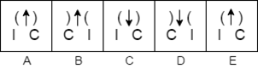

**Answer figures;**M

655

Java Try Catch

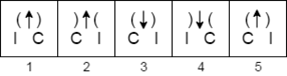

A. 1

**B.2**

C.3

D.4

E.5

**12.** Which answer figure will continue the same series as established by the problem figures?

**Problem figures;**

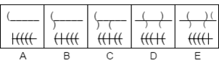

**Answer figures;**

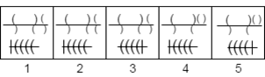

**A.1**

B.2

C.3

D.4

E.5

13.  Which answer figure will continue the same series as established by the problem figures?

**Problem figures;**

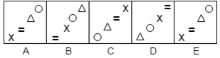

**Answer figures;**

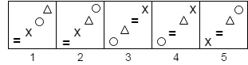

**A. 1**

B.2

C.3

D.4

E.5

**14.** Which answer figure will continue the same series as established by the problem figures?

**Problem figures;**

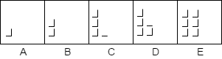

**Answer figures;**

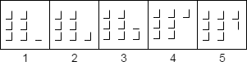

A.1

B.2

C.3

D.4

E.5

**15.**  Which answer figure will continue the same series as established by the problem figures?

**Problem figures;**

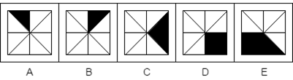

**Answer figures;**

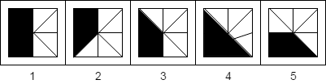

A.1

B.2

C.3

D.4

E.5

**16.** Choose the alternative which is closely resembles the mirror image of the given combination.

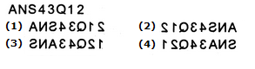

**17.** Choose the alternative which is closely resembles the mirror image of the given combination.

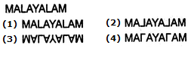

**18. What are next two letters in the given series?  
 E F H K O ? ?**  
  
**a.TZ**b.SY  
c.SX  
d. RW

**19. If first 10 alphabets of the alphabet series are written in reverse then what will come next in the given sequence  
 JZMY, IXLW, HVKU, ?**  
  
a.FSIS  
b.GTAS  
c.GSBT  
d.GTIS

**20.Fill in the blanks:**

**bof_cb_fcc_ofc_bo_cc**  
  
a.foccf  
b.foccb  
c.cofcf  
**d.** cobcf

**21.What is the next term?  
AN13,BZ24,CO12,DY21,......?**  
  
a.EP18  
b.EX18  
c.FX10  
**d.** EP11